System Assembly - TopCoder Direct Member Payments Dashboard Deployment Guide

Revision History
Author | Revision Number | Date
TCSASSEMBER | 1.0 | 04/08/2013

Deployment Instructions 3
1. Organization of Submission 3
2. Application Setup 3
2.1 Properties File 3
2.2 Build Scripts Setup 4
3. Database Setup 4
4. Deployment Instructions 5
5. Starting 5
6. Verification 5
7. Resource Contact List 7

Deployment Instructions

Organization of Submission

The submission follows directory structure provided below:

doc
Contains this document which is the Deployment Guide.

direct
Contains sources for Direct application. This directory replicates the application development distribution structure and includes only updated and new files.

db
Contains updated db files.

test_files
Contains data for test purpose.

db_patch
Contains db patch file.

Application Setup

The application is expected to be deployed to the following environment:

JRE 1.5
JBoss 4.2.3.GA
Informix DS 11.0

Properties File
Below token properties are added/removed in direct/token.properties, please modify them follow examples.

Property Name | Property description | Example Setting
@paymentsByStatusByDays@ | The days range used in payment status table | 30,60,120
@paypalPaymentMethodId@ | The paypal payment method id | 2
@payoneerPaymentMethodId@ | The payneer payment method id | 5
@westernPaymentMethodId@ | The western union payment method id | 6
@paymentsService.paymentMethodID@ | To remove it

Build Scripts Setup
The build script for Direct application (build.xml) provides the following targets which are to be used:

- switch-and-checkout – checkout or switch to the defined source code branches for all components defined in subprojects.xml
- dist-backend – rebuilt all the components from the source code.
- dist_tcs – rebuilt component from the source code.
- first_deploy – must be the first task to execute from command line. It will copy all dependencies to your local JBoss folder.
- deploy – should be the main task to execute from command line. It will build and deploy WAR file.
- deploy-static-files – deploys the static files to jboss.
- deploy-apache-static – deploys the static files to apache.

You can get more information here:
http://www.topcoder.com/wiki/display/docs/TC+Direct+Setup+Guide

Database Setup

You are supposed to update db. There are two ways to do so.

- Setup db via informix account (for details on VM see http://www.topcoder.com/wiki/display/docs/VM+Image+2.5 ). (Recommended)

  - Login into vm as informix account, you may need to login as direct account then execute “su informix -l”, the password is 1nf0rm1x
  - Copy db/* to /home/informix/scripts/, overwrite exist files.
- Note: You’d better use the same revision as me. The revision info is listed in svn_info.txt
  - Execute “cd /home/informix/scripts”
  - Execute “ant drop_db”
  - Execute “ant setup_db”

- Use Query Tool as follows (for details on Query Tool usage see http://www.topcoder.com/wiki/display/docs/TopCoder+Studio+Query+Tool+Usage):

  - Execute db_patch/patch.sql via server studio or other Informix db tools
  - After set tc.cloud.topcoder.com to your vm in hosts, visit http://tc.cloud.topcoder.com/query/query
  - Select Transactional database.
  - Update below queries with content in corresponding query files.

Query | Content
get_created_payments_trends | db\informixoltp\query_tool\query_get_created_payments_trends.txt
get_paid_payments_trends | db\informixoltp\query_tool\query_get_paid_payments_trends.txt
get_potential_member_payments | db\informixoltp\query_tool\query_get_potential_member_payments.txt
get_pullable_payments | db\informixoltp\query_tool\query_get_pullable_payments.txt
top_10_payments_summary | db\informixoltp\query_tool\query_top_10_payments_summary.txt

Deployment Instructions

This section provides the instructions in Production environment.
- Merge the direct folder from submission into SVN branch for Direct application
  - Note: You’d better use the same revision as me when deploying in VM. The revision info is listed in svn_info.txt
- Update token.properties follow section 2.1
  - Note: please copy the whole Payment Dashboard section in the end of token.properties.example to token.properties if it’s not there
- Stop jboss
  - jbb
  - ./kill.sh (input ‘y’)
  - tn (watch the jboss stop)
- Build and deploy Direct application using ant deploy (or ant first_deploy ) command.
- Copy static files using ant deploy-static-files command or ant deploy-apache-static if use apache as static file server.

Starting
In order for successful extrernal PayPal sevice invocation on VM it is needed to add some changes to JBoss run file.
Edit /home/direct/jboss/bin/run.sh file, add -Djavax.net.ssl.trustStore=$JAVA_HOME/jre/lib/security/cacerts to JAVA_OPTS variable as shown in following snippet:

# Force IPv4 on Linux systems since IPv6 doesn't work correctly with jdk5 and lower
if [ "$linux" = "true" ]; then
JAVA_OPTS="$JAVA_OPTS -Djava.net.preferIPv4Stack=true -Djavax.net.ssl.trustStore=$JAVA_HOME/jre/lib/security/cacerts"
fi

- Build and deploy the Direct application follow section 4.
- Start JBoss server instance hosting Direct application
  - Below steps are used for restart jboss in VM
    - Login VM as direct
    - jbb
    - ./kill.sh (input ‘y’)
    - tn (watch the jboss stop)
    - ./start.sh
    - tn (watch the jboss start)

Verification

You can use test_files\test_data.sql for verification, execute it via server studio or other Informix db tools.

- Open http://localhost:8180/direct/ or https://[vm_ip]/direct/, login as heffan/password.

- Visit https://{address}/direct/payments/overview.action, you should see below page as heffan doesn’t have tc accounting role.


- Logout, login as user/password, and visit https://{address}/direct/payments/overview.action again. You should see below page.
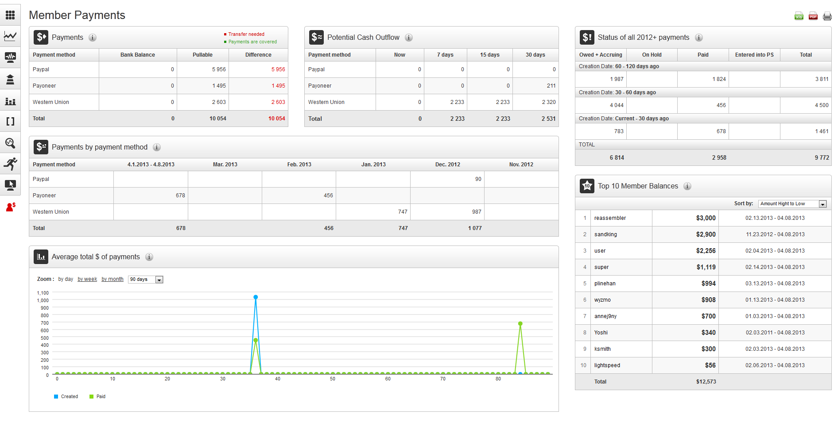

- Select different options in “Average total $ of payments” table, you can see different chart.
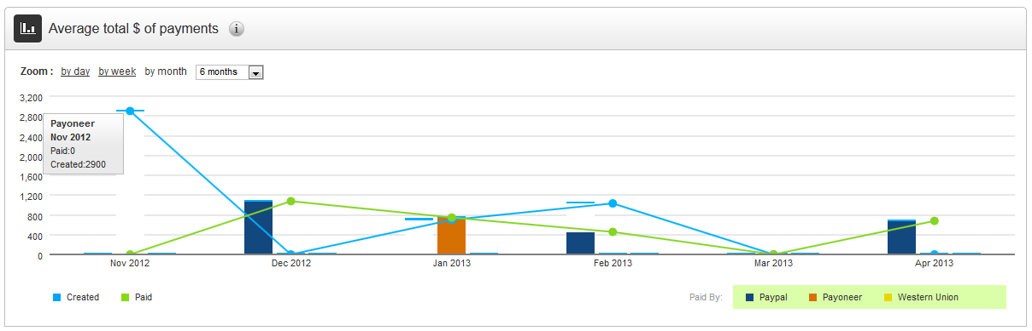

- Check other parts of this page. All should works.

- Click printer icon, you should see print page.
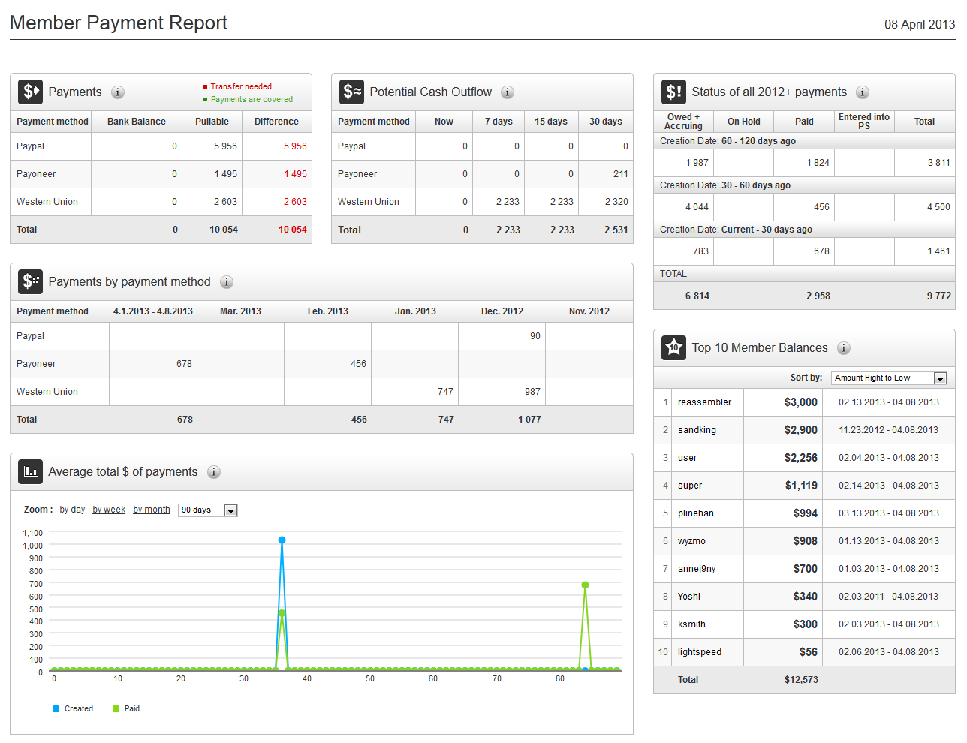

Resource Contact List

Name | Resource Email
TCSASSEMBER

